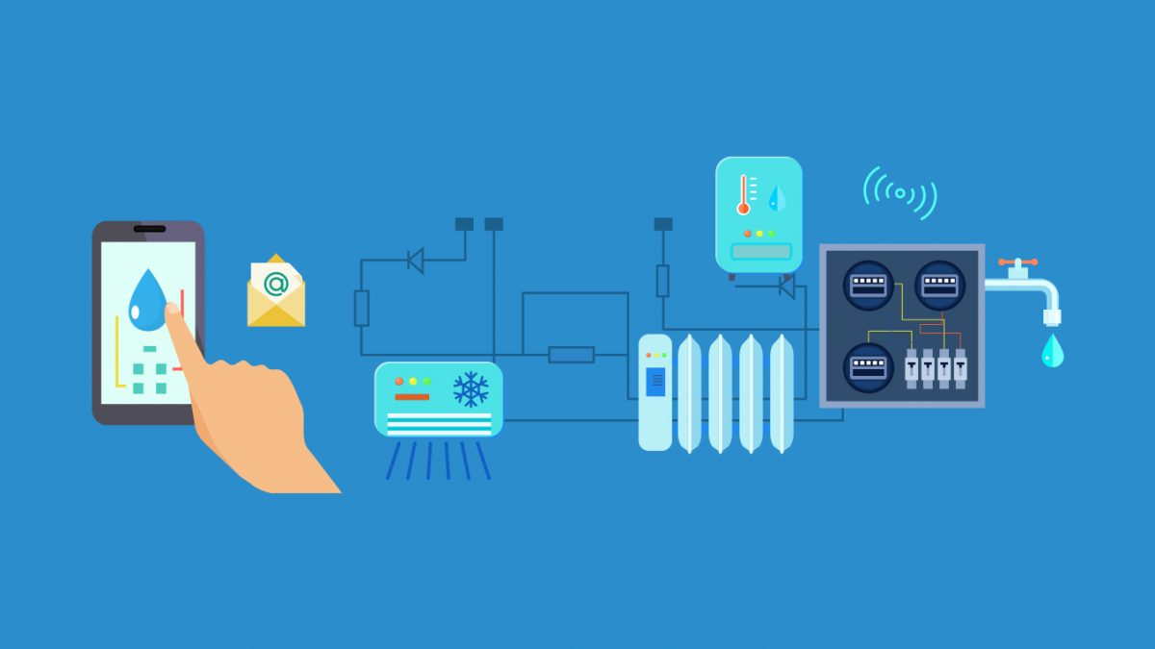

SMART WATER SYSTEM

IOT PHASE -1

PET Engineering College

# PROJECT OBJECTIVITIES:

# Real-time Water Consumption Monitoring:

Real-time water consumption monitoring refers to the continuous and immediate tracking of water usage in a given area or system. It involves the collection, analysis, and reporting of water consumption data in real-time or near-real-time, allowing for better insights into current usage patterns and the ability to respond promptly to changes or anomalies.

# Public Awareness (in the context of water conservation):

Public awareness in the context of water conservation refers to efforts and campaigns aimed at educating and informing the general public about the importance of water conservation practices. This objective involves raising awareness about the finite nature of water resources, the need to reduce wasteful consumption, and the adoption of water-saving behaviors in homes, businesses, and communities.

# Water Conservation:

Water conservation is the practice of using water resources efficiently and reducing unnecessary water waste. It involves the implementation of strategies and technologies to minimize water consumption while maintaining essential needs and services. The goal of water conservation is to ensure the sustainable use of water resources, protect ecosystems, and meet the needs of present and future generations.

# Sustainable Resource Management (in the context of water):

Sustainable resource management refers to the responsible and balanced utilization of water resources to meet current needs without compromising the ability of future generations to meet their own needs. This objective involves managing water sources, ecosystems, and infrastructure in a way that ensures long-term sustainability, considers environmental impacts, and factors in social and economic considerations.

## Step -1: Define Objectives and Requirements

### Objectives:

Real- time monitoring of water consumption.

Identifying and addressing water waste.

Pr0moting water conservation.

insuring the sustainable use of water resources.

### Requirements:

Sensor types( flow meters, pressure sensors, temperature sensors, etc.).

Data transmission and communication protocols( Wi- Fi, cellular, LoRa, etc.).

Power source( battery, solar, or wired).

Data storage and analysis platform.

User interface for data visualization.

Alarm system for abnormal water usage.

## Step -2: Sensor Selection

### Sensor Types:

Choose appropriate sensors for measuring water flow, pressure, and temperature.

Consider the reliability, accuracy, and durability of sensors.

### Communication:

Select communication protocols and technologies suitable for the deployment environment( e. g., Wi- Fi for indoor, LoRa for long- range outdoor).

### Power Source:

Determine the power source based on deployment location( battery- powered for remote areas, solar- powered for outdoor locations).

## Step -3: Sensor Deployment

### Location Identification:

Identify strategic locations for sensor placement, such as water pipes, faucets, toilets, and irrigation systems.

Ensure accessibility for maintenance.

### Installation:

Install sensors securely and according to manufacturer specifications.

Connect sensors to the chosen power source and communication network.

### Calibration:

Calibrate sensors to ensure accurate measurements.

Regularly check and recalibrate sensors to maintain accuracy.

## Step -4: Data Collection and Transmission

### Data Collection:

Collect data from the sensors in real- time or at regular intervals.

Ensure data integrity and quality control.

### Data Transmission:

Transmit data securely to a central data storage and analysis platform.

Use encryption and authentication to protect data during transmission.

## Step -5: Data Storage and Analysis

### Data Storage:

Store collected data in a secure and scalable database.

Implement data retention policies.

### Data Analysis:

Analyze water consumption patterns to detect anomalies and identify potential water waste.

Use machine learning algorithms for predictive maintenance and optimization.

## Step -6: Visualization and Reporting

### User Interface:

Develop a user- friendly interface for data visualization and reporting.

Provide access to real- time and historical consumption data.

### Alerts and Notifications:

Set up alert systems to notify stakeholders of abnormal water usage or system issues.

## Step 7: Maintenance and Optimization

### Regular Maintenance:

Establish a maintenance schedule for sensor inspection, cleaning, and replacement.

Address any issues promptly to ensure continuous operation.

### Optimization:

Use the insights from data analysis to optimize water usage and conservation efforts.

Adjust sensor placement or configuration as needed.

## Step 8: Public Awareness

### Outreach Campaigns:

Use the collected data to engage the public in water conservation efforts.

Implement educational campaigns and incentives to promote water- saving behaviors.

## Step 9: Compliance and Regulation

### Compliance:

Ensure that the IoT sensor deployment complies with local regulations and data privacy laws.

### Reporting:

Prepare reports and data for regulatory agencies as required.

## Step 10: Evaluation and Continuous Improvement

### Evaluation:

Regularly assess the effectiveness of the IoT sensor system in meeting objectives.

Real-Time Transit Information Platform:

### Design a mobile app interface that displays real-time parking availability to users.

1. **Splash Screen**
2. **Login/Registration**
3. **Dashboard**
4. **Map View**
5. **List View**
6. **Parking Details**
7. **Profile**
8. **Notification**
9. **Search and filter**
10. **About / logout.**

Maintain a tidy, user-friendly, and responsive interface. In order to refine the design and raise user satisfaction, user testing and feedback are essential. To ensure a consistent and comfortable user experience across both platforms, take into account platform-specific design guidelines for iOS and Android.

Integration Approach:

The IoT sensors will send data to the data-sharing platform in such a way:

1. **Sensor Selection**
2. **Communication Protocol**
3. **Data Format**
4. **Gateway Deployment**
5. **Data Encryption and Security**
6. **Sensor Configuration**
7. **Data Aggregation and Pre-processing ,Data Transmission**
8. **Platform Integration**
9. **Data Storage**
10. **Real-time Processing and Analysis**
11. **Dashboard and Visualization**
12. **Monitoring and Maintenance**
13. **Scalability**
14. **Documentation and Support**
15. **Provide user support and troubleshooting resources for sensor operators.**

By following in this way the integration approach between the senor and the platform will Perform well. It will define the best way to design IOT based smart water system to perform well in all circumstances.

# Conclusion:

A revolutionary advancement in the management of water resources is represented by smart water systems. These systems give us the ability to monitor, conserve, and sustainably manage our scarce water resources like never before by utilizing cutting-edge technology like IoT sensors, real-time data analysis, automation, etc. They have the potential to lessen waste, ensure effective use, and increase public awareness of the value of water conservation, which will ultimately help our planet live a more sustainable and water-secure future.